**[2CEIT503: COMPUTER NETWORK]**

Practical: 4



**AIM: Write a program to implement various framing techniques.**

**a. Bit Stuffing**

**b. Byte Stuffing**



**Department of Computer Engineering/Information Technology**

**Q.1 Byte Stuffing**

flag=input("Enter flag: ")

esc_char=input("Enter ESC Character: ")

data=input("Enter Data: ")

byte_stuff=[]

byte_stuff.append(flag)

for i in data:

    if(i==flag or i==esc_char):

        byte_stuff.append(esc_char)

    byte_stuff.append(i)

byte_stuff.append(flag)

print("Flag is: ",flag)

print("ESC is: ",esc_char)

print("Original data is: ",data)

print("ByteStuff Data is: ","".join(byte_stuff))

**Output:**

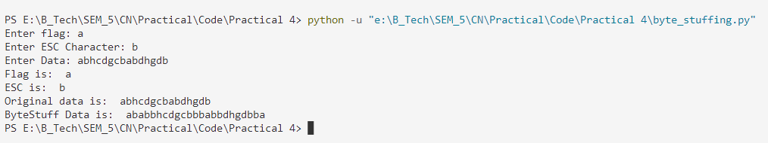

**Q.2 Bit Stuffing**

flag='01111110'

data_list = list(input("Enter Data: "))

c=0

index=0

print("Flag is: ",flag)

print("Original Data is: "+"".join(data_list))

while (index<len(data_list)):

    if(index<len(data_list)):

        if(data_list[index]=='1' and index==0):

            while (index<len(data_list)):

                if(data_list[index]=='1'):

                    index=index+1

                else:

                    break

    if(index<len(data_list)):

        if(data_list[index]=='0'):

            c=0

            index=index+1

        elif(data_list[index]=='1'):

            c=c+1

            index=index+1

        if(c==6):

            data_list.insert(index-1,'0')

            c=0

print("Bit Stuff Data is: ",flag,"".join(data_list),flag)

**Output:**

